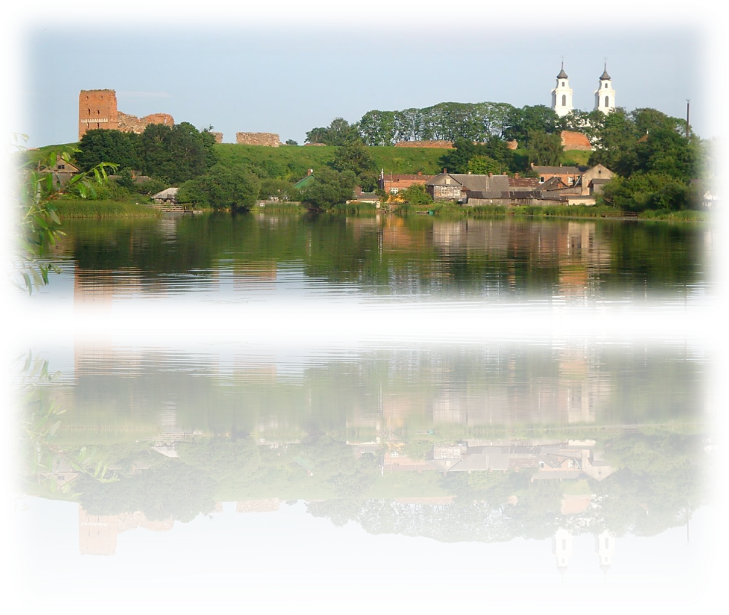
Association “Ludza District partnership”

Association “Ludza District partnership” actively participate in the Rural Development Programme for Latvia 2014.-2020 activity “Implementation of actions in accordance with the community-led local development strategy” in such activities:
- Development of entrepreneurship/ Initiatives for strengthening of local economy, including development of agricultural produce processing, home production and crafts in relation to tourism industry and preservation of cultural heritage
- Diversification of social activities/ Initiatives for development of local potential, including preservation of environmental and natural resources.

LEADER projects submitted in 2016 (activity 1):
- Creation of workshop for reconstruction and restoration of wooden products
- Construction of slaughterhouse on the farm “Granti”
- Creation of trading place for home compounder production in Ludza
- “Hello in the Salnava manor” (Improvement of manor for tourism)
- Construction of self-service car wash
- Quick freezing and storage of berries and vegetables
- Creation and development of tourism services in the farm of J. Šicāns
- Diversification of veterinary services
- Arrangement of rural tourism infrastructure and establishment of new services on the farm “Ezerzeme”
- Centre of ideas, initiatives and craftsman in the Salnava manor (craft and local food)
- Processing of turkey meat
Projects are submitted by legal and natural persons, the existing companies and newly established enterprises. Project amount up to 100000 EUR. Aid intensity for business projects - 70%, joint projects - 80%.
We offer itineraries about realized LEADER projects depending on required themes. More information: www.ludzaspartneriba.lv

Legal address:Zaļāseglītes, Malnavas parish, Kārsavas municipality, Latvia, LV- 5717
Actual address:Raiņa street 16- 418, Ludza, Ludza municipality, Latvia, LV- 5717
Coordinator: Sandra Palma
Mobile phone number: +371 29413335
E- mail: ludzaspartneriba@apollo.lv, ludzaspartneriba@inbox.lv
